**ACAMP**

**Automated Care**

**And**

**Monitoring of Plants**

|  |  |
| --- | --- |
| **Justin Johnson**  Electrical Engineering  [jurjohns@ucsc.edu](mailto:jurjohns@ucsc.edu) | **Stark Pister**  Computer Engineering  [spister@ucsc.edu](mailto:spister@ucsc.edu) |
| **Wayland He**  Computer Engineering  [whe3@ucsc.edu](mailto:whe3@ucsc.edu) | **Daniel Gunny**  Electrical Engineering  [dgunny@ucsc.edu](mailto:dgunny@ucsc.edu) |

**Purpose**

**Why Hydroponics**

As the supply of fresh water decreases and the amount of arable land is diminished, solutions are needed to continue the production of plants and food. ACAMP's goal is to develop a system that requires little to no interaction by the user while optimizing the growth of the plant. Hydroponics is a particularly environmentally-friendly form of plant cultivation as far less water is consumed in the hydroponics process compared to traditional means of cultivation. Water is recycled and used repeatedly, reducing the amount of water wasted substantially. ACAMP intends on building a custom web interface, where the user will be able to select the settings that best fit the environment the plant thrives in. An exotic food can be grown locally instead of being flown in from across the globe. In addition to an adjustable environment, users can also observe the growth of their plants through a webcam inside the growth chamber.

**Why Automation is Important**

Automation of the hydroponic growth cycle eases the growth process, opening the door to gardening for a whole range of people: inexperienced growers, people lacking time, people lacking the outdoor space to grow, and people who demand precision in their growth process. Automation ensures that the environment will always be optimized while operating at a much higher level of efficiency. We believe that the automation ACAMP provides will revitalize an interest in subsistence agriculture.

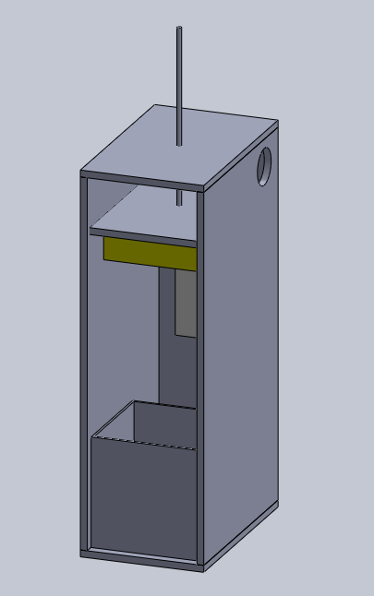**Visual Overview**

This is a simplified version of what we imagine our project to be. While the door is missing, the graphic shows the general framework, the reservoir/grow table, and the adjustable light. The dimensions of the structure were intended to allow the structure to be moved through most doors.